Smooth and nimble cutting through sheet metal

- Housing parts of Metabo cordless shears and nibblers made from polyamide 6 from LANXESS
- High-quality, strong material
- Thin walls made from compound with a high filler content
- Good surface quality

Cologne, February 23, 2021 – Craftsmen understand the importance of lightweight, powerful and accurate power tools. Tailor-made high-performance plastics are the material of choice for the production of these tools. The SCV 18 LTX BL 1.6 cordless sheet shears and the NIV 18 LTX BL 1.6 cordless nibbler from Metabo are perfect examples for this. The Nürtingen-based manufacturer of professional power tools has added these devices to its range of cordless cutting tools. “The housing shells and the upper and lower shells of the batteries for both tools are made from our polyamide 6 Durethan materials. These injection molding compounds enable the complex, compact and highly functional housing parts to be manufactured in such a way that they weigh very little, are robust enough to deal with everyday tasks and are at the same time visually appealing,” explains Bernhard Stoll, expert in the use of plastics in electrical and electronic components at LANXESS.

Weight savings for more battery cells

The black upper shell of the 18V battery, for example, is made from Durethan BKV50H2.0EF, a flow-optimized polyamide 6 with a 50 percent by weight glass fiber content. “The advantage of our highly reinforced material is its good flowability, which enables the creation of very thin walls in addition to excellent surface qualities, despite the high glass fiber content. The excellent mechanical properties of the compound, such as rigidity and strength, also remain largely unaffected by humidity,” says Stoll. The high rigidity of the material also means considerable weight savings as a result of the thin walls. The low weight also improves the handling and balance of the tools.

Green and bright red

The lower shell of the battery is injection-molded from Durethan BKV30Q. In addition to its mechanical properties, it was the red color, the high surface quality and the cost-effective processability that gave the standard compound the edge. By contrast, the slim and high-grip half-shells of the device housing are made from impact-resistant modified Durethan BKV130CS. Despite the 30% glass fiber reinforcement, this copolyamide 6 also produces flawless surfaces. They are colored in a special Metabo green, which, together with the bold red of the lower battery shell, reinforces the tool manufacturer's color branding. Like the other materials, the compound is characterized by its high rigidity across a wide temperature range. According to Stoll, “This makes the housings resistant to impacts and shocks, as confirmed by the typical drop tests for such tools.”

Both the cordless shears and the cordless nibbler facilitate daily work – whether on the roof or on the facade, in the sanitary and heating sector, in ventilation and air conditioning technology or in vessel construction. Tinsmiths, for example, can use the tools to work sheet metal for flue flashing directly on-site. In this case, the SCV 18 LTX BL 1.6 cordless sheet shears excels in cutting flat sheets, and the NIV 18 LTX BL 1.6 cordless nibbler in the handling of corrugated and trapezoidal sheets. The cuts are produced without flying sparks or build-up of heat. They neither deform the material nor damage the paint or the coating.

Further information on the new cutting tools can be found at www.metabo.de. Details on products, developments, technologies and services from the Durethan series can be found at www.durethan.de and www.hiant.de.

Images

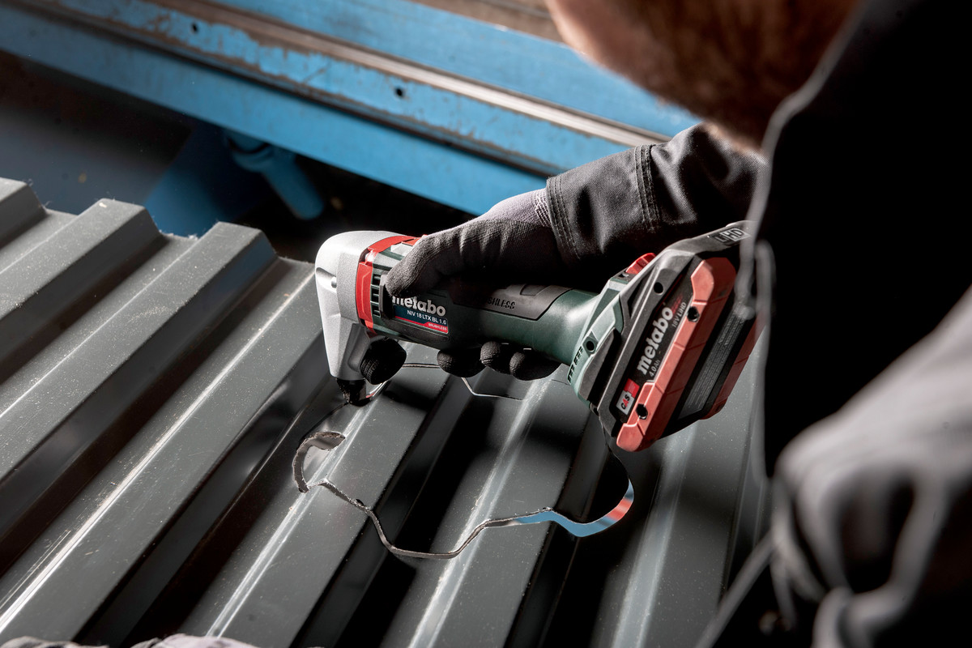

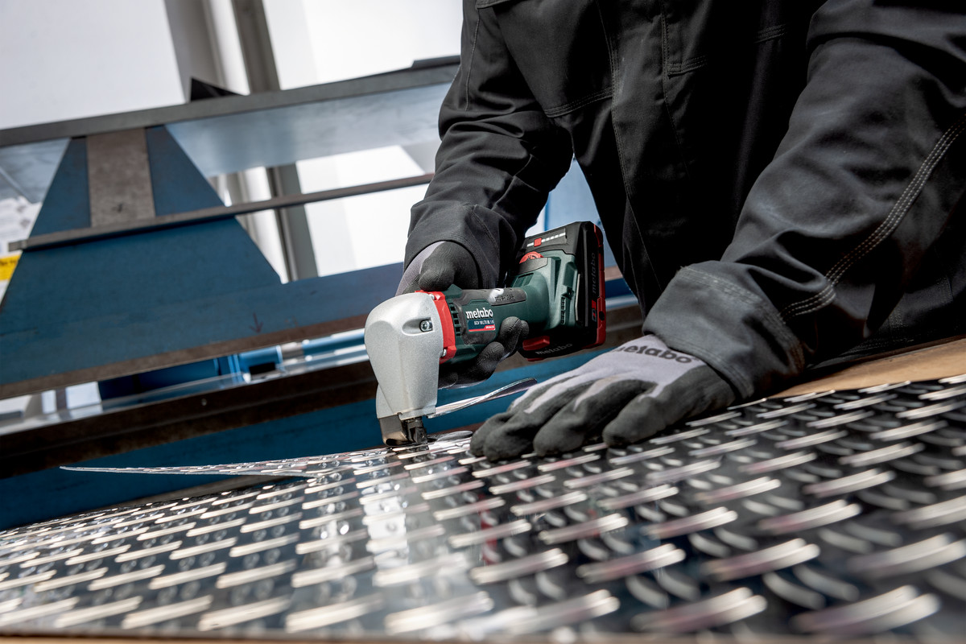

The cordless nibbler is the perfect choice for working corrugated and trapezoidal sheets, and the cordless sheet shears are ideal for cutting flat sheets. The housing shells and the upper and lower shells of the batteries for both tools are made from polyamide 6 Durethan materials from LANXESS. Photos: Metabo

LANXESS is a leading specialty chemicals company with sales of EUR 6.8 billion in 2019. The company currently has about 14,400 employees in 33 countries. The core business of LANXESS is the development, manufacturing and marketing of chemical intermediates, additives, specialty chemicals and plastics. LANXESS is listed in the leading sustainability indices Dow Jones Sustainability Index (DJSI World and Europe) and FTSE4Good.

Cologne, February 23, 2021
mfg/rei

Forward-Looking Statements
This company release contains certain forward-looking statements, including assumptions, opinions, expectations and views of the company or cited from third party sources. Various known and unknown risks, uncertainties and other factors could cause the actual results, financial position, development or performance of LANXESS AG to differ materially from the estimations expressed or implied herein. LANXESS AG does not guarantee that the assumptions underlying such forward-looking statements are free from errors, nor does it accept any responsibility for the future accuracy of the opinions expressed in this presentation or the actual occurrence of the forecast developments. No representation or warranty (expressed or implied) is made as to, and no reliance should be placed on, any information, estimates, targets and opinions contained herein, and no liability whatsoever is accepted as to any errors, omissions or misstatements contained herein, and accordingly, no representative of LANXESS AG or any of its affiliated companies or any of such person's officers, directors or employees accepts any liability whatsoever arising directly or indirectly from the use of this document.

Information for editors:
All LANXESS news releases and their accompanying photos can be found at http://press.lanxess.com. Recent photos of the Board of Management and other LANXESS image material are available at http://photos.lanxess.com.

You can find further information concerning LANXESS chemistry in our WebMagazine at http://webmagazine.lanxess.com.

Follow us on Twitter, Facebook, Linkedin and YouTube:

http://www.twitter.com/LANXESS
http://www.facebook.com/LANXESS
http://www.linkedin.com/company/lanxess
http://www.youtube.com/lanxess

